Dis-Eur-Crete-Minoan snake goddess-Figurines

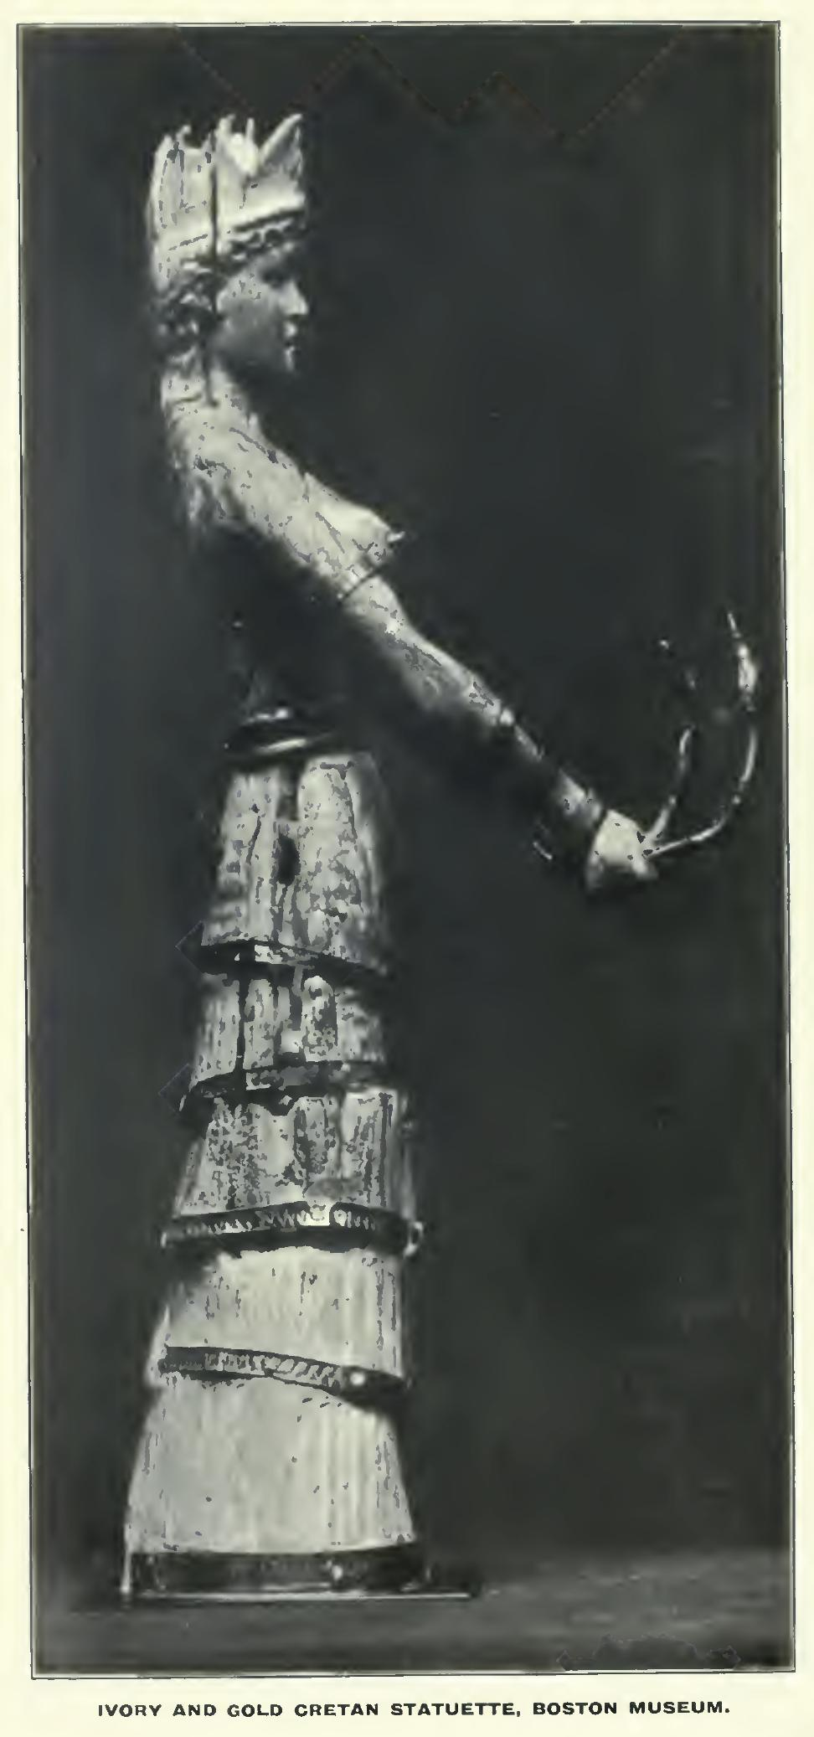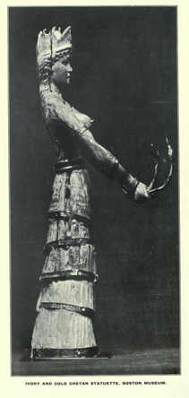

[Ernest Arthur Gardner](https://en.wikipedia.org/wiki/Ernest_Arthur_Gardner) (1862–1939) - Ancient Egypt, 1913, [page 281](http://www.archive.org/stream/ancientegy1914to17brituoft#page/n281/mode/1up)

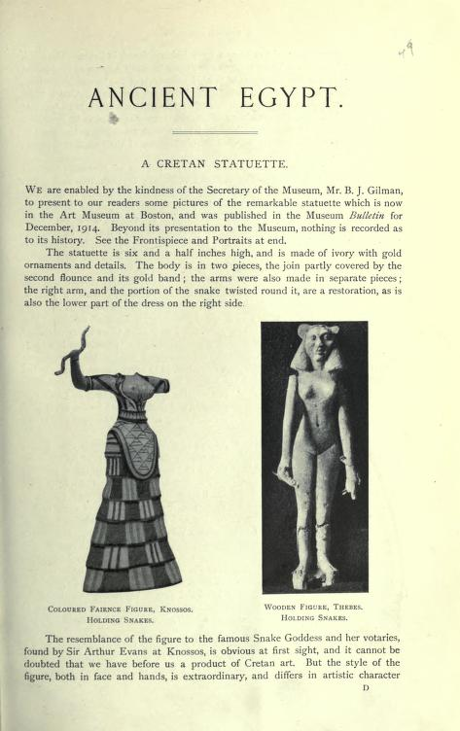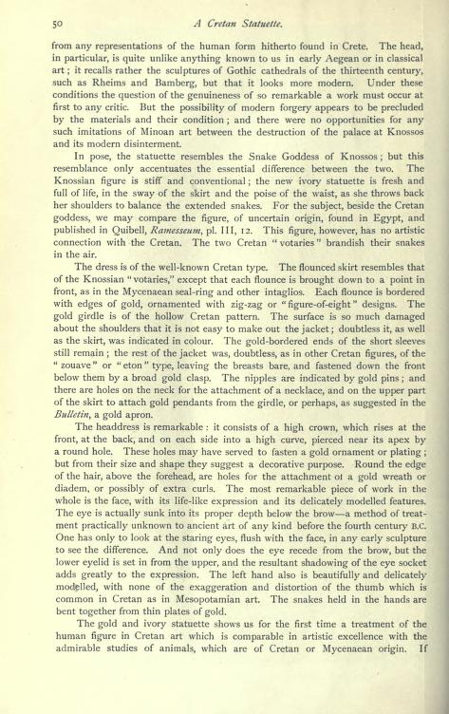

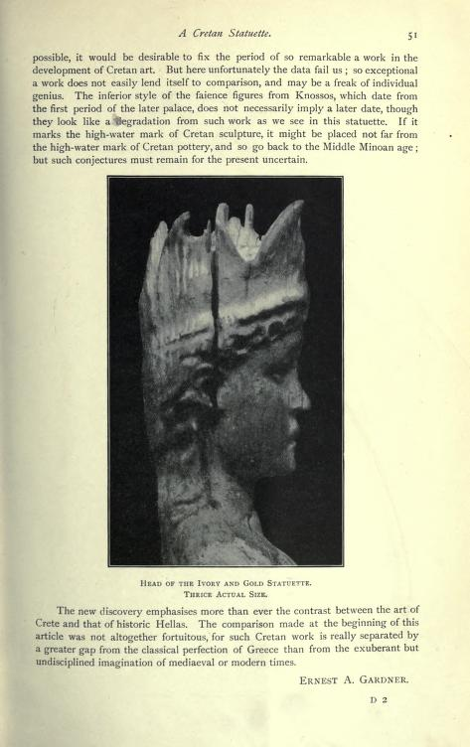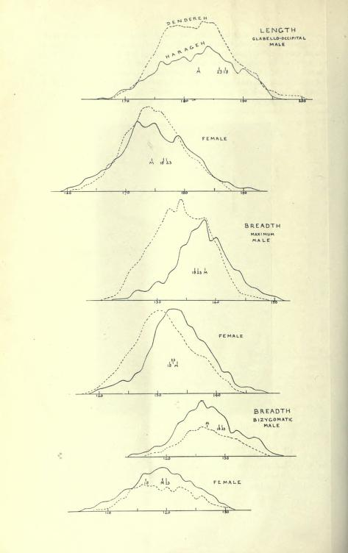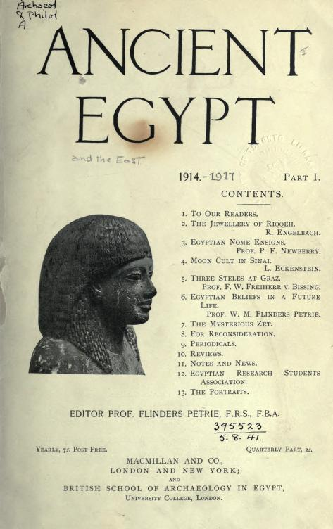

This article is 1916.

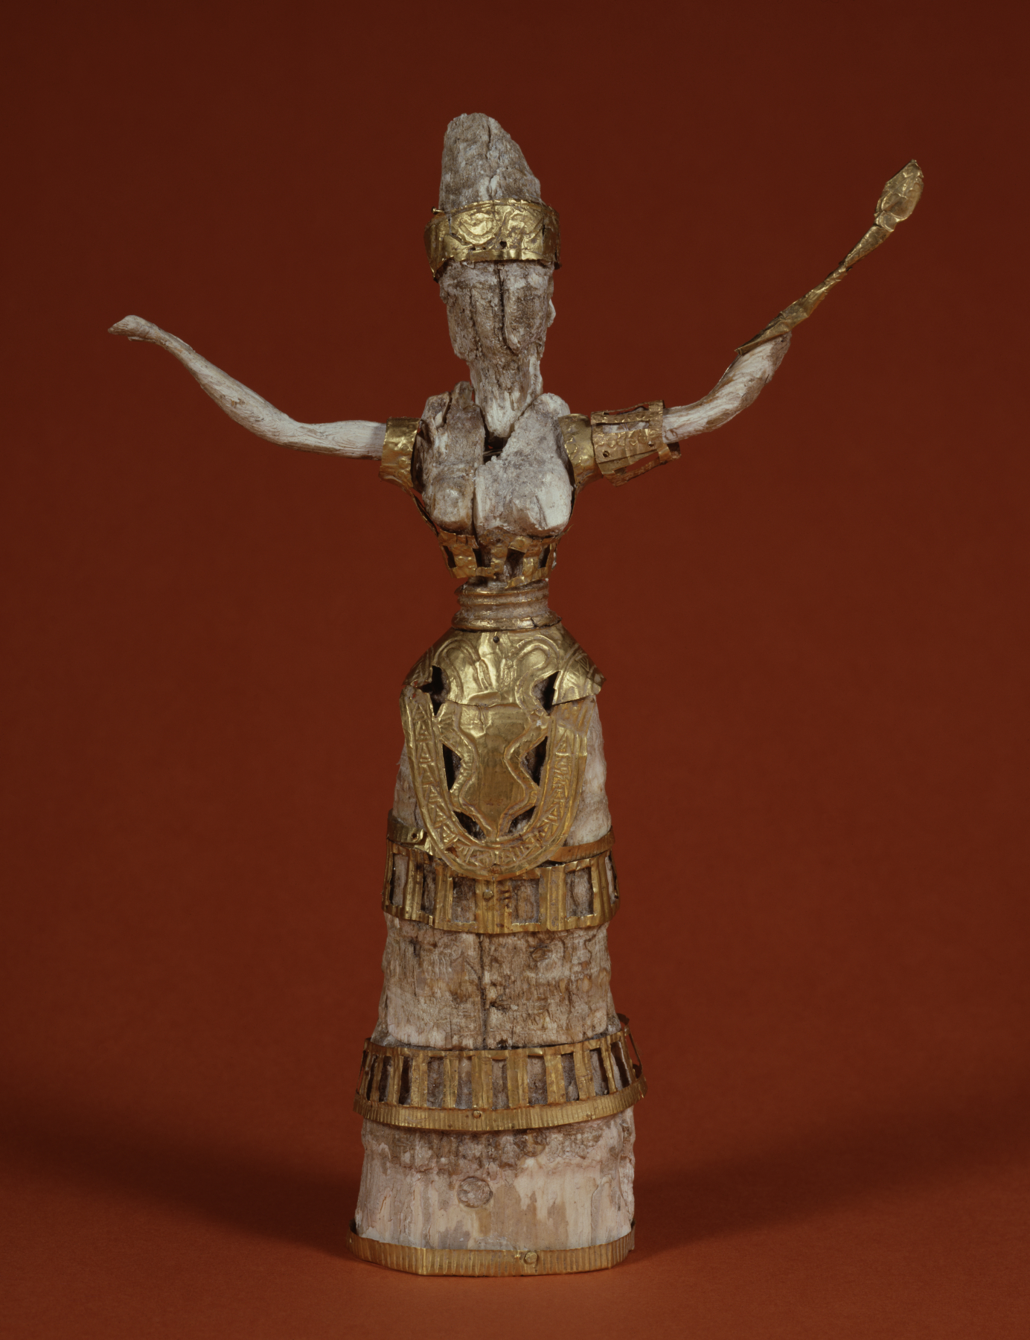

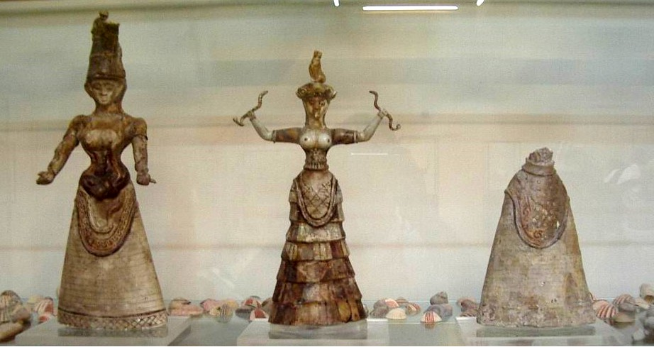

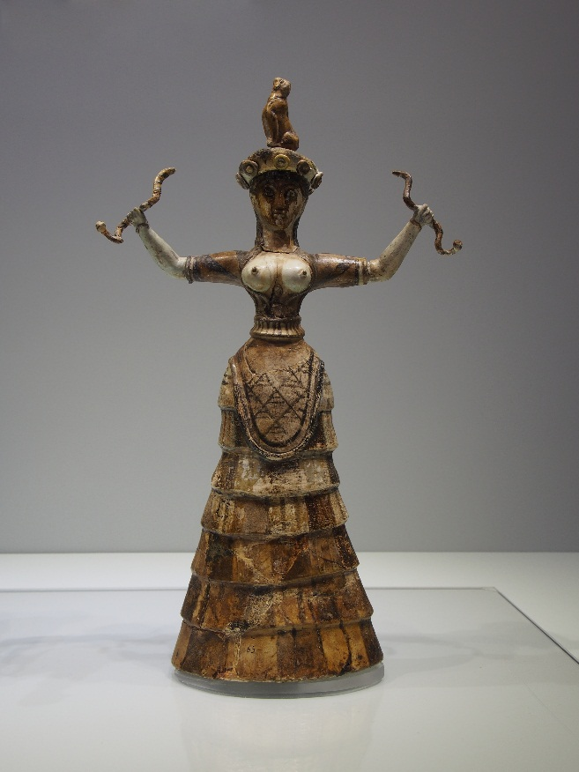 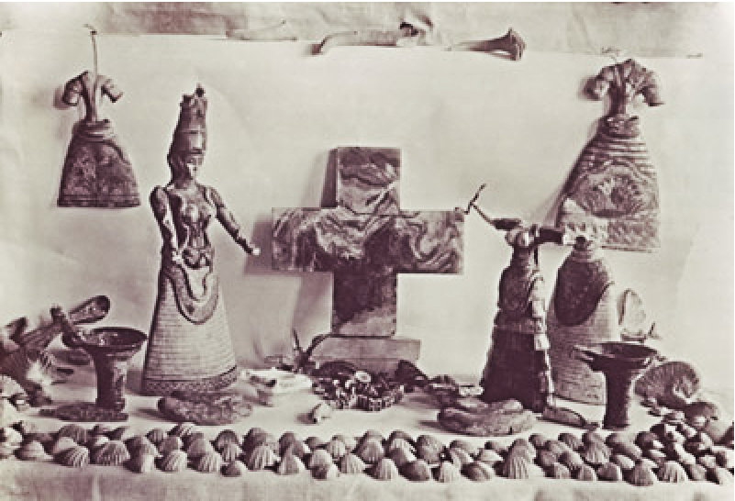

**Minoan Snake Goddess**   
from Knossos, Crete  
c. 1600 BCE   
faïence   
height 131/2 inches (34.3 cm)   
(Archeological Museum, Herakleion)